From CNET Reviews

http://news.cnet.com/8301-17938_105-57390886-1/best-24-inch-monitors/

Best 24-inch monitors
by Eric Franklin March 5, 2012 3:44 PM PST
With 16:10 aspect ratios, 24-inch monitors find themselves an increasingly endangered species these days; it's good to know which ones stand ahead of the pack.

The Dell UltraSharp is a great performer
Monitors that are 24 inches with 16:10 aspect ratios are a dying breed. Their slow demise makes way for the new world order of 16:9.
While the 16:9 aspect ratio and the 1,920x1,080-pixel resolution more closely matches that of movies and mimics HDTVs, some users still find value in the extra screen real-estate afforded by 16:10-based, 1,920x1,200-pixel resolution.
As long as there is enough demand, 1200p monitors will continue to be made, but they're nowhere near as plentiful as say four years ago. With fewer to choose from than before, knowing which are the best is where I and this blog come in, could be very helpful.
Personally, I prefer 24-inch displays at 16:10, but the 16:9 aspect ratio makes 2,560x1,440-pixel resolution possible so it can't be all bad.
You may notice that I didn't include the HP DreamColor LP2480zx on the list. It's the best-performing 24-inch I've ever seen. Its price, unfortunately, puts it out of reach for the majority of users.
Given that, I've only included monitors on the list most average people could afford.

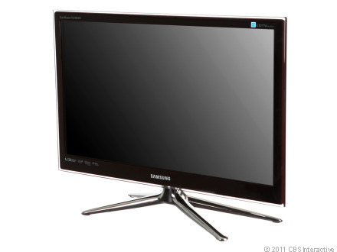
Monitor/HDTV combos usually look a lot like small HDTVs. I guess the HDTV gene is stronger.
(Credit: Josh Miller/CNET)
Samsung SyncMaster FX2480HD
This is still my favorite monitor/HDTV so far. Besides its great movie performance, I think what really appeals to me is that the FX2490HD feels like a miniaturized HDTV, from its connection layout to its chrome, four-pronged foot stand. Read the full review.

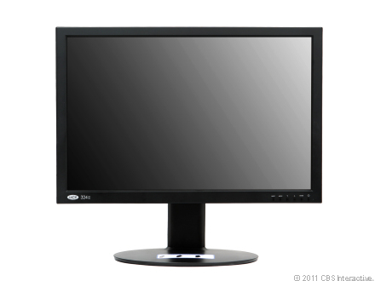
The i324 is a behemoth. Luckily, it has the performance to justify its price.
(Credit: Josh Miller/CNET)
Lacie i324
The i324 is one of the best-performing IPS displays I've ever had the pleasure of viewing. Deliciously deep blacks and excellent color reproduction deliver picture quality second to only a scant few. Unfortunately, its price is a little steep for the features it offers. Read the full review.

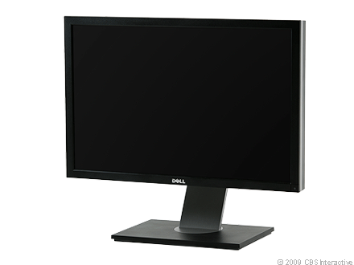
Overly high expectations may have soured its initial reception, but the U2410 is a more than capable monitor.
(Credit: Josh Miller/CNET)
Dell UltraSharp U2410
While it probably won't cure any diseases or align the planets, bringing about a "Bill and Ted"-like era of peace, the U2410 has tons of connections and a great price-to-performance ratio. If you find yourself disappointed at its less-than-messiah-like qualities, be sure to check out the accompanying video and know that others feel your pain as well. Read the full review.

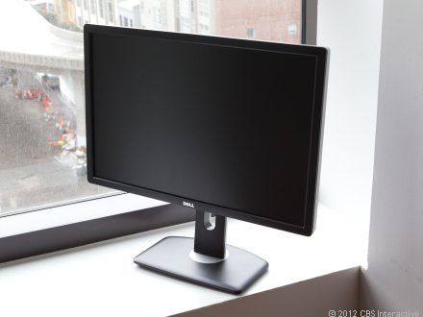
The king of value! Also, great at taking depressingly sad rainy-day pictures.
(Credit: Josh Miller/CNET)
Dell UltraSharp U2412m
When it comes down to it, it's the price. OK, it's not just the price. Great performance with plenty of ergonomic and OSD options make it an impressive deal for its price. If this thing were another $150, you wouldn't even be reading about it right now. Read the full review.

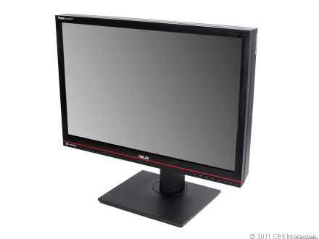
(Credit: Josh Miller/CNET)
Asus PA246Q
The best of all worlds: affordable price, impressive performance, and enough unique and useful features (like the grid overlay) to make its already easily digestible price go down that much smoother. Read the full review.

Looking for specs and pricing? Compare these monitors head-to-head.
Shop for products mentioned in this post on CNET.com:
LaCie 324i — $1,149.00 - $1,699.00
Dell UltraSharp U2412m — $329.00 - $358.23
HP DreamColor LP2480zx — $2,444.93 - $2,924.99
Dell UltraSharp U2410 — $539.99 - $601.75
Asus PA246Q — $479.00 - $539.95
Eric Franklin
Eric Franklin is senior editor covering monitors and tablets and also manages CNET's San Francisco testing lab. When not reviewing the latest products in his categories, he's usually gaming, system building (you know, desktop PCs), working out, or imagining himself as one of an interchangeable cadre of super-powered individuals performing really cool-looking actions in slow motion.
Read more: http://news.cnet.com/8301-17938_105-57390886-1/best-24-inch-monitors/#ixzz1oSIHU5Cn

Full Review of Specific Monitors

Samsung SyncMaster FX2490HD
- Review
- User Reviews
- Specifications
- Compare

CNET Editors' Rating
3.5 stars

Very good

Average User Rating
3.5 stars
2 reviews
As shown: $573.00
See manufacturer site for availability
Set price alert
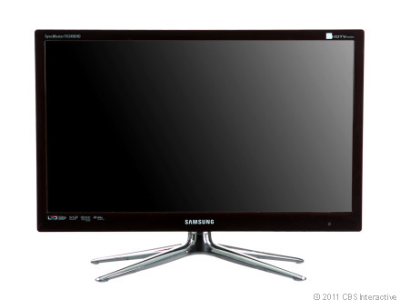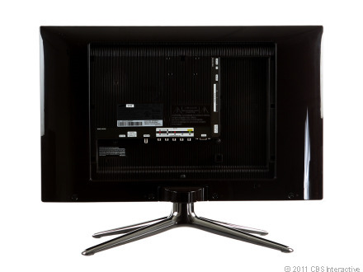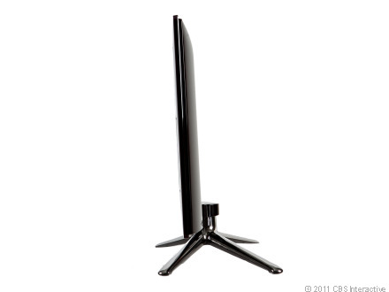
Scroll LeftScroll Right

CNET Editors' Review
- Want it (3)
- Got it (1)
- Had it (0)

CNET Editors' Rating
3.5 stars Very good

- Design: 7.0
- Features: 8.0
- Performance: 8.0
- Service and support:8.0
- Reviewed by: Eric Franklin
- Reviewed on: 11/03/2010
The good: The Samsung SyncMaster FX2490HD has an impressive number of connection options, built-in speakers, and a remote control, with great movie and game performance. It also has a couple of design flourishes that contribute to not only its aesthetic appeal, but to its utility as well.
The bad: The Samsung SyncMaster FX2490HD requires color calibrating to get the picture quality to an acceptable level; its lack of DVI connection means you'll need to purchase an adapter or new cord to get it working with a modern PC. Some of its connection options are frustratingly difficult to reach.
The bottom line: The Samsung SyncMaster FX2490HD is a 24-inch HDTV doubling as a monitor for a low price.
Review:
The Samsung SyncMaster FX2490HD has performance that rivals the Samsung PX2370, one of the best TN monitors we've tested. The FX2490HD has some of the best movie and games performance we've seen recently; it also has a near full assortment of HDTV connection options, including two HDMI ports and built-in speakers. The lack of a DVI port means you'll need to do some finagling to get HDMI working properly on a PC and you'll definitely need to spend some time calibrating colors before the HDTV monitor is working at its full potential. Still for $419, Samsung ... Expand full review
The Samsung SyncMaster FX2490HD has performance that rivals the Samsung PX2370, one of the best TN monitors we've tested. The FX2490HD has some of the best movie and games performance we've seen recently; it also has a near full assortment of HDTV connection options, including two HDMI ports and built-in speakers. The lack of a DVI port means you'll need to do some finagling to get HDMI working properly on a PC and you'll definitely need to spend some time calibrating colors before the HDTV monitor is working at its full potential. Still for $419, Samsung offers essentially a 24-inch television at a very appealing price.
Design and features
The 24-inch Samsung SyncMaster FX2490HD has a semiglossy maroon chassis with angular corners and a clear plastic overlay on the bezel. With the overlay, the bezel measures 0.8 inch wide on the right and left sides. The initial depth of the panel is 0.6 inch, but it extends back to include the connection options, adding another 0.8 inch, for a total of 1.4 inches of depth. That's quite thin, considering the number of connection options included. The distance from the bottom of the bezel to the desktop is 3.1 inches, and the panel tilts back 10 degrees and swivels right and left 30 degrees, but no other ergonomic options are included. The monitor's full width measures 22.6 inches, a little wider than the Samsung PX2370.
The foot stand's legs are made of chrome and come in the shape of an "X." When knocked from the sides these do a good job keeping the monitor from falling over, but the panel still wobbles a lot when knocked. The back of the display has an easily removable, but seemingly pointless, cover that reveals the connection options aligned both vertically and horizontally. They include two HDMI ports, component and composite ports, a coaxial antenna in, an optical audio port, a headphone jack, a USB port, and an Ex-link port. Though the vertical connections are easy to access, the horizontal ones are tucked under enough that connecting them proved frustrating most of the time. At the top portion of the back are four holes to attach the monitor, VESA-style, to a wall or stand.
The monitor's onscreen display array is located on the bottom right side of the panel and consists of several touch areas/buttons, including a Menu button, a Source button, an Up and Down button, and a Plus and Minus button. Attempting to use the array to navigate the OSD, however, is a frustrating experience: the buttons aren't as sensitive as we'd like, they must be touched on the underside of the bezel, and there isn't an onscreen menu that lines up next to them to guide you. We found it easiest to navigate the OSD with the remote control. The options function very much like a typical Samsung HDTV; however, when connected to a PC, picture options include controls for brightness, contrast, and sharpness, and presets include Custom, Dynamic Contrast, Text, Internet, and Entertain. Also, there's a color temperature option, allowing you to choose Cool, Normal, Warm, and custom. The custom color temperature allows you to adjust the red, blue, and green values individually. Its audio options include presets for Music, Movie, Standard, Amplify, and Clear Voice. In addition, there's an audio equalizer, allowing for granular fine-tuning of the sound.
Design highlights
Connectivity | HDMIx2, VGA, component, composite, coaxial antenna in
Ergonomic options: | 10 degree back tilt, Swivel
Resolution | 1,920x1,080 pixels
Aspect ratio: | 16:9
Audio | Built-in speakers, headphone jack, optical audio
VESA support | Yes

Feature highlights
Included video cables? | VGA
Backlight | LED
Panel Type | TN
Screen film | Matte
Number of presets | 5
Overdrive | No
Picture options | Brightness, Contrast, Sharpness
Color controls | Color temperature, RGB controls
Gamma control | Yes
Additional features | Included remote control, Ex-link jack
Performance
DisplayMate performance: We tested the 24-inch Samsung SyncMaster FX2490HD through its HDMI input, connected to a Windows Vista PC using a HDMI cable supplied by our own vast array we've collected over the years. The display posted a composite score of 93 on CNET Labs' DisplayMate-based performance tests, a couple of points lower than the Samsung PX2370's 96. In Color Tracking, we noticed an obvious green tint that carried over to movie watching. We were able to alleviate this by adjusting the Red and Green attributes, detailed in the Recommended settings and use section.
Also, in our Extreme Grayscale Bars test, we noticed an adequate amount of white-level saturation, meaning that near peak white, the monitor would be capable of distinguishing colors and not wash them out. Its black level was only visible down to a level 4, however, and not level 2, as would be optimal. The Dark Screen test displayed noticeable amounts of backlight breakthrough on the top and bottom middle edges of the screen. Also, in our Motion Bitmaps test we saw slightly more streaking on the FX2490HD than the PX2370 showed; however, this did not carry over to our real-world games and movie tests.
Text: In text, we saw no color problems with black text on a white background. Fonts were visible down to a 6.8-point size.
Movies: We tested the Samsung FX2490HD in its Movie preset, using the Blu-ray version of "Avatar." The Samsung displayed dark detail just as well as the PX2370, missing none of the Na'vi's braids during the bonfire scene. What stood out most was the apparent green push, noticeable in character faces, making them appear sickly compared with the healthy-looking faces on the PX2370; however, we were able to make some color and settings adjustments that improved things greatly. Check out the Recommended settings and use section for more details.
Games: Because of our intimate familiarity with World of Warcraft (WoW), it remains the best tool for judging color quality and vibrancy in games. We looked at WoW in the Samsung SyncMaster FX2490HD's Entertainment preset and found that it delivered vibrant imagery and no hint of the green color tint problem after calibration.
Photos: The Samsung SyncMaster FX2490HD's Custom preset displayed photos that lacked red in faces and looked noticeably greenish. After calibration, things improved greatly, but we were still unable to get red to look as accurate as on the PX2370.
Sound: The built-in speakers were capable of producing loud, clear music and dialogue that was crisp and easily intelligible. Although you can adjust the frequency for the sound, the bass was noticeably lacking.
Hide Review
Next page
Pros: This is an Excellent monitor!!!!!!
Here is the monitor page as well as the Full Spec sheet page info: http://www.samsung.com/us/computer/monitors/LS24F9NSM/ZA, http://www.samsung.com/us/system/consumer/product/ls/24/f9/ls24f9nsmza/FX2490HD_DSHT.pdf
Cons: The design of the Samsung FX2490HD is very slim and styish, but the design also makes this monitor appear smaller than other 24in monitors in it's class even though it is a 24in monitor that is larger than most stock monitors that people purchase.

Summary: First I think this monitor deserved a better score than three and half stars. Eric Franklin always does this wobble movement test on monitors. I understand that a monitor needs to not only feel like it is made of high quality materials, but unless you live in a high earthquake area or have a lot of children running around knocking over stuff. I don't think he should take away from the monitor by hitting the side of it to test the movement of the monitor. I don't think people plan on knocking over there monitors. In the review he did for the HP w2408h he criticized the monitor's rotating feature because the picture did not rotate. First your PC, laptop or internet device has to have this feature or be able to use that feature for the picture to rotate. So I would say the monitor was not hooked up to a device capable of that. Most monitors don't rotate anyway or at least most people use regular monitors that may only lean forward, back, turn left and right or raise up and down. Even though the Samsung FX2490HD does not raise up and down and only tilts back a little and not that much forward, most people aren't going to be looking at a monitor from the floor or ceiling. Plus if that is the case a lot of monitors can be wall mounted like most HDTV's. I don't like the fact that he knocks it for not having a DVI connection. I understand that most PC gamers need this to view their games at a higher quality, but most HDTVs, monitors even PC's or laptops, cameras, and other various electronics that use cables require you to purchase higher quality cables to get the best picture or video possible anyway. And sure some eletronics include the cables or connections that people want but most don't have everything included. And also some PC's DVI output often do not support HDMI audio so the owner of the PC would have to buy an extra cable or adapter anyway.
I DID NOT see any green tent or color when watching a HD DVD, Blu-Ray DVD & DVD movie during playback! And that was before I decided to mess with the calibration options on this monitor. And with almost any HDTV/Monitor or video/picture type electronics the user often with have to calibrate it to their liking so I don't see how this monitor could be knocked for that.
One fact is that the correct Full Resolution is: 1920x1080p not 1920x1440 and the correct Dynamic Contrast Ratio is:5,000,000:1 not 1,000,000:1
I confirmed this through a chat session on the Samsung website and through looking at the real Spec sheet, which I put a link up for this in my pros section for this monitor. My experience with this monitor so far has been Excellent. I couldn't ask for a better monitor!
Viewing angle: The optimal viewing angle for a monitor is usually directly in front, about a quarter of the way down from the top of the screen. At this angle, you're viewing the colors and gamma as the manufacturer intended. Most monitors are not made to be viewed at any other angle. Depending on the panel type, picture quality at nonoptimal angles varies. Most monitors use TN panels, which get overly bright or overly dark in parts of the screen when viewed from nonoptimal angles, making for inaccurate color representation. The Samsung SyncMaster FX2490HD uses a TN panel, and when it is viewed from the sides or bottom, we perceived the screen to darken about 6 inches off from center, which is typical for a TN.
To help out with this somewhat, Samsung includes the Magic Angle feature in the FX2490HD. The Magic Angle mode prevents the screen from darkening when viewed from certain angles. Magic Angle has four settings: Lean Back Mode 1, Lean Back Mode 2, Standing Mode, and Side Mode. Switching to each mode will improve the screen brightness when viewing the monitor from that angle. For example, after switching to Lean Back Mode 2 and then sitting back in your chair to play a game, the screen doesn't darken nearly as much, and as a result, game details can still be seen, while you do irreparable damage to your spine, all in the name of "fun."
Recommended settings and use: The Samsung SyncMaster FX2490HD doesn't include a DVI input and by default, only the VGA input is optimized to be used with a PC. To optimally use a digital connection with a PC, go into the Source menu, choose Tools > Edit name > choose whichever HDMI connection you wish to use, then select PC. Fonts and edges will look PC proper after that.
During general use, we preferred the standard, default settings of the Custom preset. When watching movies, playing games, and viewing photos, the best settings for the Samsung SyncMaster FX2490HD was the default settings with the preset set to Entertain, the Red to 55, Green to 36, and Blue to 50. Photos still had an accuracy problem with red at these settings, and unfortunately we were unable to find the perfect photos settings.
As with most TN-based monitors, the SyncMaster FX2490HD shouldn't be used if pinpoint-accurate color reproduction is required; however, the monitor is great for watching movies, casually viewing photos, and for general use, although it's not the best for playing games. If you do have stringent color needs, we suggest you narrow your search to IPS or PVA-based panels only. The more expensive Dell UltraSharp U2711 is a good place to start.
Power consumption: The Samsung SyncMaster FX2490HD achieved fair power consumption, with a Default/On power draw of 31.4 watts, compared with the Samsung PX2370's 25.01 watts in the same test. The consumption delta was a lot closer in our Sleep/Standby test, with the FX2490HD drawing 0.23 watt and the PX2370 costing a slightly higher 0.27 watt. With both monitor's center point calibrated to 200 candelas per square meter (cd/M2), the FX2490HD drew 27 watts, whereas the PX2370 drew a lower 19.9 watts. Based on our formula, the Samsung SyncMaster FX2490HD would cost $9.53 per year to run, compared with the Samsung PX2370's $7.65 per year.
Juice box
Samsung SyncMaster FX2490HD | Average watts per hour
On (default luminance) | 31.4
On (max luminance) | 31.4
On (min luminance) | 19.8
Sleep | 0.23
Calibrated (200 cd/m2) | 27
Annual power consumption cost | $9.53
Score | Fair
Brightness in cd/m2
(Longer bars indicate better performance)
Samsung SyncMaster XL2370
344
Samsung PX2370
246
Samsung SyncMaster FX2490HD
239
HP 2310e
234
Samsung SyncMaster BX2350
219
Gateway FHD2303L
212
Dell ST2420L
207
LG Flatron E2350V
197
Contrast ratio
(Longer bars indicate better performance)
LG Flatron E2350V
1,355:1
Gateway FHD2303L
1,195:1
HP 2310e
1,110:1
Dell ST2420L
1,061:1
Samsung SyncMaster XL2370
1,008:1
Samsung SyncMaster FX2490HD
983:1
Samsung PX2370
948:1
Samsung SyncMaster BX2350
885:1
DisplayMate Tests
(Longer bars indicate better performance)
Samsung PX2370
97
Samsung SyncMaster XL2370
96
Samsung SyncMaster BX2350
96
LG Flatron E2350V
94
HP 2310e
93
Samsung SyncMaster FX2490HD
93
Gateway FHD2303L
89
Dell ST2420L
87
Find out more about how we test LCD monitors.
Service and support
Samsung backs the SyncMaster FX2490HD with a three-year parts-and-labor warranty that covers the backlight. It also offers support through a 24-7 toll-free number, as well as 24- to 48-hour turnaround time for e-mail and Web chat support. The display's documentation and support software are available on Samsung's Web site.
Read more: http://reviews.cnet.com/lcd-monitors/samsung-syncmaster-fx2490hd/4505-3174_7-34201070-2.html#ixzz1oSLfWJtp

Specifications

- Manufacturer: Samsung
- Part Number:FX2490HD

General
- Display Type TFT active matrix
- Diagonal Size 24 in
- Viewable Size 24
- Built-in Devices Stereo speakers ,
TV tuner
- Aspect Ratio Widescreen
- Native Resolution 1920 x 1440
- Brightness 250 cd/m2
- Color Support 16.7 million colors
- Response Time 5 ms
- Horizontal Viewing Angle 170
- Vertical Viewing Angle 160
- Backlight Technology LED backlight
- Controls & Adjustments Power on/off
- Features HDCP,
MagicEco,
Crystal Clear,
HDTV compatible,
MagicAngle,
Picture in picture,
Touch of Color (ToC)
- Color Mystery brown
- Dimensions (WxDxH) 22.8 in x 8.5 in x 14.3 in,
- With stand
- Weight 11.69 mg

Audio
- Type speaker(s) - Stereo - Integrated
- Output Power / Channel 5 Watt

Connectivity
- Interfaces VGA,
HDMI,
DVI-D,
Component video,
Composite video
- Connections - D-Sub,
- DVI-Digital,
- Component video,
- Composite video,
- HDMI,
- VGA

Mechanical
- Display Position Adjustments Tilt
- Flat Panel Mount Interface 75 x 75 mm

Miscellaneous
- Features Wall mountable
- Microsoft Certifications Compatible with Windows 7
- Compliant Standards DDC-2B

Power
- Form Factor External

Software / System Requirements
- Min Operating system Microsoft Windows 7

Dimensions & Weight
- Dimensions & Weight Details With stand - 22.8 in x 8.5 in x 17.2 in x 11.7 lbs,
Without stand - 22.8 in x 1.4 in x 14.3 in

Sustainability
- CNET Labs: Operational power consumption 31.4 Watt
- CNET Labs: Calibrated power consumption 27 Watt
- CNET Labs: Max brightness power consumption calibrated 31.4 Watt
- CNET Labs: Min brightness power consumption 19.8 Watt
- CNET Labs: Power consumption Stand by / Sleep 0.23 Watt
- CNET Labs: Estimated Annual Energy Cost 8.36 US Dollars
- EPA Energy Star Compliant Yes

LaCie 324i
- Review
- Specifications
- Compare
- Shop

CNET Editors' Rating
3.5 stars

Very good
Starting at: $1,149.00
- $1,349.00
B&H Photo-Video
- $1,349.00
PCNation.com
- $1,399.00
LexJet
- $1,323.94
eBay
All prices Set price alert
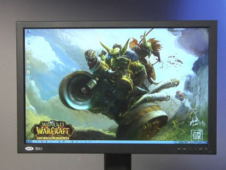
Scroll LeftScroll Right

CNET Editors' Review
- Want it (0)
- Got it (0)
- Had it (0)

CNET Editors' Rating
3.5 stars Very good

- Design: 7.0
- Features: 6.0
- Performance: 9.0
- Battery life: 7.0
- Reviewed by: Eric Franklin
- Reviewed on: 12/06/2010
The good: The LaCie 324i provides accurate color, deep blacks, and a host of ergonomic options.
The bad: The LaCie 324i takes some tweaking to minimize its green push. Also, for its price and size it offers less value than other monitors in its class.
The bottom line: The LaCie 324i is a decently priced pro monitor that performs well but unfortunately can't compete in bang-for-buck terms with offerings from Dell and NEC.

For about $1,150, the LaCie 324i offers performance and ergonomic design you'd expect from a professional monitor. It includes sRGB and Adobe RGB presets, a black-level control, and color temperature, RGB, and gamma options. The 10-bit panel exhibited a deep black level and accurate and vibrant color (once calibrated). It can't quite compete with the HP DreamColor LP2480zx in color performance or the NEC MultiSync PA271W in useful OSD features. Also, compared with the Dell UltraSharp U2711, the LaCie 324i can't match its lower price and has a smaller screen. The LaCie 324i is a very well-designed, excellently performing monitor that just doesn't come close enough to offering as much value as its contemporaries.
Design and features
The 24-inch LaCie 324i looks like a typical performance monitor; a monitor focused on color accuracy and gamut, black level and contrast. So, yes, by "typical," we mean a thick, hefty panel and a dark chassis. Pretty much par for the course when it comes to performance monitors these days.
Delving into the details, said panel measures 1.9 inches in depth initially, extending another 1.6 inches for the connection options, bringing its total to a substantial 3.5 inches. The panel sits on a 12.2-inch-wide oval footstand, with a depth of 9.8 inches.
The left and right bezel measure 0.8 inch in width and the dark gray chassis has a smooth finish all around. The full width of the panel is 22.2 inches, about the same as the HP DreamColor LP2480zx.The display includes a full range of ergonomic support, featuring screen height adjustment, 35-degree back tilt, 45-degree left and right swivel, and 90-degree pivot to the right. The distance from the desktop to the bottom of the panel is 2.4 inches at its lowest and 6.7 inches at its highest. All of the adjustments were simple and easy to make, save possibly for pivoting, which requires the screen be in its highest range before properly functioning.
The LaCie 324i stood its ground quite well when knocked from the sides or from behind, as long as the screen was at its lowest height. Pull the screen up a few inches and you'll find a very wobbly monitor when knocked; however, thanks to its hefty 23-pound weight, it never seemed to be in any real danger of toppling.
Connection options include DVI, HDMI, DisplayPort, and Component. There are also two USB upstream ports and one downstream port. All connections are located on the back of the panel, facing downward, making them difficult to access unless you pivot the monitor or at least raise its height.
The lower right-hand corner of the bezel holds the onscreen display (OSD) array, consisting of five buttons aligned horizontally. Navigating the OSD took only a short time to get used to and we were soon able to easily browse through its extended offerings. These include Brightness, Contrast, Black Level, Color Temperature, and Gamma. Presets include User, sRGB, Adobe RGB, Calibration, and Grayscale. Also included is a feature that adjusts the monitor from a 4:3 to a 16:10 aspect ratio. There are also many options for customizing the OSD, including controls for its position, transparency, and duration on screen.
While the OSD offers some useful options, there's nothing here approaching the depth of options the NEC MultiSync PA271W provides.
The OSD buttons have a strong tactile and audible response with each button press and felt soft enough that our fingers didn't sting after using them for extended periods.
Design highlights:
Connectivity: DVI, HDMI, DisplayPort, Component
Ergonomic options: 35-degree back tilt, 45-degrees swivel, 90-degree pivot, 4-inch screen height
adjustment range
Resolution: 1,920x1,200
Aspect ratio: 16:10
Audio: Audio In ports
VESA wall-mount support: No
Feature highlights:
Included video cables? DVI
Backlight: CCFL
Panel Type: P-IPS (10 bit panel)
Screen film: Matte
Pixel-response rate: 6ms
Number of presets: 5
Overdrive: Yes
Picture options: Brightness, Contrast, and Black Level
Color controls: Direct color temperature control, RGB controls
Gamma control: Yes
Additional features: Optional cover and colorimeter
Performance
We tested the LaCie 324i through its DVI input, connected to a Windows Vista PC, using the included DVI cable. The display posted a composite score of 97 on CNET Labs' DisplayMate-based performance tests, one point lower than the HP DreamColor LP2480zx. The 324i faltered a bit in our Color Tracking test, compared with the LP2480zx. Unlike the LP2480zx, the 324i showed a green tint at default settings; however, with a bit of RGB tweaking, we were able to minimize this effect. The 324i also delivered deep blacks in our black-level test, displaying down to a level-two gray--which is two levels above true black. And while the LP2480zx delivered a very small amount of backlight bleed-through, clouding was obvious in the upper middle edges of the 324i's screen when displaying a dark screen. As with the LP2480zx, we saw little evidence of color banding in our color ramp test, which tests a panel's ability to render gradations of primary colors in a smooth and consistent manner.
Text: We saw no color problems with black text on a white background. Fonts were clearly visible down to a 6.8 size and looked slightly clearer than the same fonts on the HP DreamColor LP2480zx.
Movies: We tested the LaCie 324i using the Blu-ray version of "Avatar." In the movie, we saw accurate color and deep color in the User preset with only a slight green push, which we were easily able to alleviate with only a small tweak of the green and blue values. Blacks were impressively dark without missing any of the detail of the Na'vis' hair during the nighttime bonfire scene.
Games: Because of our intimate familiarity with World of Warcraft (WoW), it remains the best tool for judging color quality and vibrancy in games. The 324i delivered a picture with a high level of color saturation in the default User preset. This gave the colors a vibrancy typical of larger IPS monitors like the Dell UltraSharp U2711 and NEC MultiSync PA271W. We also used DisplayMate's Motion tests and found that the 324i, with its 6-millisecond G2G refresh rate, produced as much movement streaking as the LP2480zx, which also has a 6ms G2G refresh rate. Both monitors displayed more streaking than the Samsung PX2370 in the same test.
Read more: http://reviews.cnet.com/lcd-monitors/lacie-324i/4505-3174_7-34327823.html#ixzz1oSJpK4uB
Photos: The 324i delivered high-resolution photos with deep and accurate colors that were not quite as good as what the HP LP2480zx delivered. We had to jack up the blue and tone down the green before they no longer distracted us.
Viewing angle: The optimal viewing angle for a monitor is usually directly in front, about a quarter of the screen's distance down from the top. At this angle, you're viewing the colors as the manufacturer intended them. Most monitors are not made to be viewed at any other angle. Depending on its panel type, picture quality at nonoptimal angles varies. Most monitors use TN panels, which get overly bright or overly dark in parts of the screen when they are not viewed from optimal angles. On the other hand, IPS panels usually show only minimal color shifts with angle changes. The LaCie 324i has a 10-bit LG P-IPS (Performance-In Plane Switching) panel, and when viewing it from the sides, we perceived the screen as darkening about 15 inches off from center--more than twice as wide a viewing angle as a typical TN panel has.
Recommended settings and use: During general use or when playing games, we found the User preset, with the following attributes, to be the 324i's optimal setting:
Brightness | Contrast | Black Level | Gamma | Red | Green | Blue
28 | 50 | 50 | 2.2 | 50 | 50 | 50
When watching movies or viewing photos, we still preferred the aforementioned settings, augmented with the following attributes:
Red | Green | Blue
50 | 40 | 60
As with most IPS-based monitors, LaCie gears the 324i mostly toward professional use where accurate color reproduction is required; however, the monitor is also great for watching movies, playing games, viewing photos, and general use. One of its trump cards is its 10-bit panel, which allows for much more accurate color by increasing the amount of gradients of the colors the display is capable of producing.
Power consumption: The LaCie 324i achieved poor power consumption, with a Default/On power draw of 68.6 watts, compared with the HP DreamColor LP2480zx's 62.6 watts in the same test. In our Sleep/Standby test, the 324i costs 2.67 watts and the LP2480zx pulled a lower 1.97 watts. Based on our formula, the LaCie 324i would cost $22.32 per year to run, compared with the HP DreamColor LP2480zx's $20.05 per year. Although their respective default power draws didn't have a huge delta between them, it's the consumption during sleep/standby (the state the monitor is in most of the time) that really hurt the 324i. During that time, the 324i drew 26 percent more power than the LP2480zx did in the same state. Still, not much of a difference in price.
Brightness in cd/m2
(Longer bars indicate better performance)
Dell UltraSharp U2410
434
LaCie 324i
358
NEC MultiSync PA271W
346
Samsung SyncMaster PX2370
344
Dell UltraSharp U2711
333
HP LP3065
302
HP DreamColor LP2480zx
230
Contrast ratio
(Longer bars indicate better performance)
HP DreamColor LP2480zx
1,036:1
NEC MultiSync PA271W
1,035:1
Samsung SyncMaster PX2370
1,008:1
Dell UltraSharp U2711
947:1
LaCie 324i
937:1
Dell UltraSharp U2410
921:1
HP LP3065
654:1
DisplayMate tests
(Longer bars indicate better performance)
HP DreamColor LP2480zx
98
NEC MultiSync PA271W
98
Dell UltraSharp U2711
98
HP LP3065
97
LaCie 324i
97
Samsung SyncMaster PX2370
96
Dell UltraSharp U2410
94
Juice box
LaCie 324i | Average watts per hour
On (default luminance) | 68.6
On (max luminance) | 111.1
On (min luminance) | 47.8
Sleep | 2.67
Calibrated (200 cd/m2) | 68.4
Annual power consumption cost | $22.32
Score | Poor
Find out more about how we test LCD monitors.
Service and support
LaCie backs the 324i with a three-year parts-and-labor warranty that covers the backlight, which is the same great deal other vendors, such as HP and Dell, provide. It also offers 24-hour Web-based support and phone support limited to 10 hours a day, five days a week. LaCie provides free shipping and will admirably send you a replacement unit before actually receiving your defective unit. To top that off, it also pays for the shipping of both the unit shipped in and the one shipped out.
Read more: http://reviews.cnet.com/lcd-monitors/lacie-324i/4505-3174_7-34327823-2.html#ixzz1oSLGKR4r
Specifications
- Manufacturer: LaCie Ltd.
- Part Number:342i

General
- Display Type TFT active matrix
- Diagonal Size 24 in
- Built-in Devices USB hub
- Panel Type P-IPS
- Aspect Ratio Widescreen - 16:10
- Native Resolution 1900 x 1200
- Pixel Pitch 0.27 mm
- Brightness 400 cd/m2
- Image Contrast Ratio 1000:1
- Color Support 1.07 billion colors
- Response Time 6 ms
- Horizontal Viewing Angle +89 / -89
- Vertical Viewing Angle +89 / -89
- Color Temperature 9500K,
8500K,
5000K,
7000K,
10000K,
7500K,
6500K,
9000K,
4000K,
6000K,
8000K,
5500K,
4500K
- Controls & Adjustments Power on/off,
Color temperature,
Input select,
Gamma correction,
Saturation,
Sharpness,
Brightness,
Contrast,
Hue,
Black level
- OSD Languages Russian,
Spanish,
English,
German,
French,
Italian
- Features 98% Adobe RGB color gamut,
Picture in picture,
10-bit gamma,
102% NTSC color gamut
- Dimensions (WxDxH) 24.5 in x 18.1 in x 9.6 in
- Weight 24.25 lbs
- Bundled with LaCie blue eye colorimeter

Audio
- Type - External,
None

Input
- Type None

Connectivity
- Interfaces DisplayPort,
DVI-D,
HDMI,
Audio line-in,
Audio line-out,
USB upstream ( Type B ),
USB downstream,
Component video / audio ( RCA )
- Connections - USB,
- HDMI,
- DVI-Digital,
- port,
- Component video input,
- Audio input,
- Speaker-out

Mechanical
- Display Position Adjustments Tilt,
Swivel,
Height
- Flat Panel Mount Interface 100 x 100 mm

Miscellaneous
- Included Accessories Detachable hood
- Cables Included 1 x DVI cable,
1 x USB cable
- Compliant Standards WEEE,
FCC,
EN 61000-3-2,
UL,
CSA,
EN 60950-1,
EN55022,
GOST,
EN55024,
EN 61000-3-3,
ISO 13406-2,
CB,
ICES,
RoHS

Power
- Form Factor Internal
- Voltage Required AC 120/230 V ( 50/60 Hz )
- Power Consumption Operational 100 Watt
- Power Consumption Stand by / Sleep 2 Watt

Software / System Requirements
- Software type LaCie blue eye pro,
Drivers & Utilities

Manufacturer Warranty
- Service & Support 3 years warranty
- Service & Support Details Limited warranty - 3 years

Sustainability
- CNET Labs: Operational power consumption 68.6 Watt
- CNET Labs: Calibrated power consumption 68.4 Watt
- CNET Labs: Max brightness power consumption calibrated 111.1 Watt
- CNET Labs: Min brightness power consumption 47.8 Watt
- CNET Labs: Power consumption Stand by / Sleep 2.67 Watt
- CNET Labs: Estimated Annual Energy Cost 22.65 US Dollars

Dell UltraSharp U2410
- Review
- User Reviews
- Specifications
- Compare
- Shop

CNET Editors' Rating
4.0 stars

Excellent

Average User Rating
3.0 stars
16 reviews
Starting at: $539.99
- $544.99
Newegg.com
- $539.99
Amazon.com
- $542.87
eBay
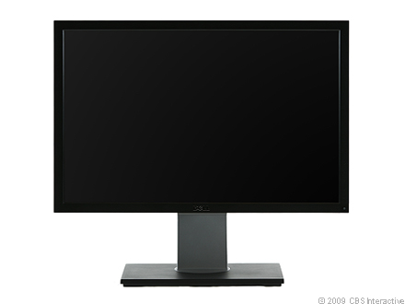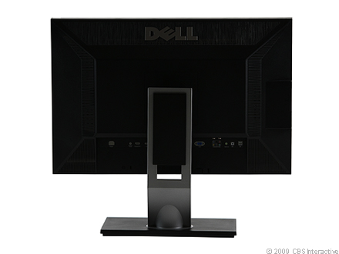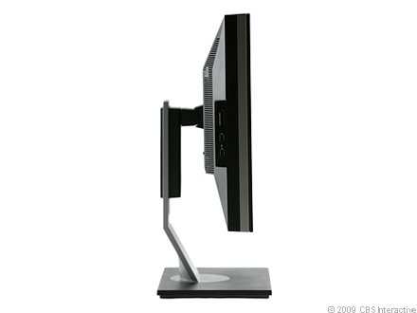
Scroll LeftScroll Right

CNET Editors' Review
- Want it (1)
- Got it (4)
- Had it (0)

CNET Editors' Rating
4.0 stars Excellent

- Design: 7.0
- Features: 9.0
- Performance: 8.0
- Service and support:8.0
- Reviewed by: Eric Franklin
- Reviewed on: 11/11/2009

Nov 09The good: The Dell UltraSharp U2410 has a plethora of connection options and ergonomic features.
The bad: The Dell UltraSharp U2410 has a slightly narrow viewing angle when compared with other IPS and VA monitors. It also has a slight pink tint and its RGB presets produce dithering when viewing dark gray colors.
The bottom line: The Dell UltraSharp U2410 is a feature-rich monitor that performs great while watching movies and playing games.

About $600 for the Dell UltraSharp U2410 gets you a 24-inch, H-IPS monitor with great performance in games and movies, a host of connection options and ergonomic features, and a robust OSD. Unfortunately, its RGB presets are marred by dithering when viewing dark gray images and the screen has a slight pink tint. Also, its viewing angles, while good, are not quite up to the standard we expect from IPS monitors. There were very high expectations for this monitor, so if you're looking for perfect performance, keep looking. However, if you desire a monitor that, despite a few quibbles, still has great performance and a huge host of useful features, for a decent price, look no further. If you don't mind skimping on connections, ergonomic options or a wider viewing angle, the Samsung SyncMaster XL2370 is $300 less and excels at games, movies, and office tasks.
Design and features
The 24-inch Dell UltraSharp U2410 has a matte, black chassis with a gray highlight running through the middle of the panel. The panel is 1.75 inches deep; however, the back of the display--which houses the backlight, connection options, and ventilation system--extends another 1.5 inches, bringing the full monitor depth to about 3.25 inches. The panel width measures 22 inches long--about average for a monitor of this screen size and the same width as the Dell UltraSharp 2408WFP. The surface of the screen is slightly frosted and smooth matte finish. The bezel measures 0.75 inch long on all sides.
The rectangular footstand measures about 12.2 inches wide by 7.8 inches deep. As such, wobbling was nearly nonexistent when we knocked the monitor from the sides, even with the monitor's height set to its maximum setting. With the screen height at its lowest, the distance from the bottom of the bezel to the desktop is 1.25 inches; at its highest, it is 5.1 inches.
The panel swivels about 70 degrees left and right and tilts back about 25 degrees. The panel can be disconnected from the stand and mounted (VESA-style) on the wall. Also, the panel pivots 90 degrees to the left for portrait mode.
Dell includes a plethora of video connection options for the U2410, all located on the back on the panel, including two DVI ports, a VGA, a HDMI, a DisplayPort, and a set of Component and Composite connectors. The only missing option is the S-Video connection, originally included on the 2408WFP. Also included are two downstream USB ports, one upstream USB port, an audio out port, and a speaker port. Accessing these connections proved fairly easy, especially when the panel is pivoted 90 degrees to the left. On the left side of the panel are two additional USB downstream ports and one card reader port compatible with xD-Picture cards, MMC cards, SD cards, and Sony Memory Sticks.
The onscreen display follows Dell's label-free design seen in many recent Dell monitors. Five buttons line the lower right-hand corner of its bezel. Pressing any of the buttons brings up the OSD, which pops up parallel to the button array, and each option corresponds to one of the four buttons. Once a new menu comes up, the function of the buttons changes dynamically, as the top two buttons become the up-and-down arrow buttons used to navigate through the newly seen menu. Since any button labels for the OSD are actually on the screen (and which would be on the bezel of other displays), calibrating the display in a dark room was painless.
Thanks to the low sensitivity of the OSD buttons on the U2410, it was sometimes necessary to press them harder than we were used on other Dell monitors. Also, the opposite seemed true for the power button. Located directly below the OSD, there were more than a few times we mistakenly shut off the monitor while attempting to calibrate it.
OSD options include the standard brightness, contrast, and various other color options. The presets are separated into two categories: Graphics and Video. There are six Graphics presets to choose from: Standard, Multimedia, Game, Warm, Cool, Adobe RGB, sRGB, and Custom. Its Video presets are: Movie, Game, and Nature. The presets don't change anything other than the red, green, and blue color balance; therefore, how well each setting works is subjective, although there are some glaring consequences for choosing either of the RGB presets. These are detailed in the performance section. There are options to adjust the hue, sharpness, and color saturation as well as additional options for setting the OSD to stay onscreen up to a minute (useful for anyone who will spend a good amount of time calibrating).
The Dell UltraSharp U2410's 16:10 aspect ratio has a 1,920x1,200-pixel native resolution. The 16:9 monitor trend currently sweeping the market has given many smaller monitors higher resolutions than they were capable of at 16:10 aspect ratio. A 22-inch monitor with a 16:9 aspect ratio now has a potential high-definition, native resolution of 1,920x1,080 (1080p) pixels as opposed to 1,680x1,050 pixels. Despite this, the Dell U2410 retains its 16:10, 1,920x1,200-pixel resolution that many users still prefer, but it also includes a 16:9 (1,920x1,080 pixel) mode for watching movies.
Manufacturer's specifications:
Resolution: 1,920x1,200
Pixel-response rate: 6ms
Contrast ratio: 1,000:1
Brightness: 400cd/m2
Connectivity: DVIx2, VGA, HDMI, DisplayPort, Component, Composite
HDCP compliant? Yes
Included video cables? DVI, VGA, DisplayPort
Backlight type: CCFL
Panel type: H-IPS
Aspect Ratio: 16:10
Performance
We tested the Dell UltraSharp U2410 with its DVI connection in the Standard (default) preset. The display posted a composite score of 94 on CNET Labs' DisplayMate-based performance tests. The U2410 scored well in nearly all of our color and uniformity tests, but we found that it tends to compress colors at the light end of various color scales. Also, we noticed that the monitor displayed a slight pink tint in our color-tracking test.
The Dell UltraSharp U2410 achieved a brightness score of 434 candelas per square meter (cd/m2)--higher than Dell's claimed 400 cd/m2 maximum. Adjusting the brightness to 100 yields a very bright screen and we recommend setting the brightness to no higher than 60 for most tasks as prolonged eye exposure to this screen above 50 percent brightness--especially if doing a lot of Excel or Word (or any white screen program) work--may result in eye strain.
We looked at "Kill Bill: Vol. 1" on DVD and several 1080p movie files from Microsoft's WMV HD Showcase. Movies looked great on the Dell thanks to the display's deep blacks and colors looked fuller and more natural than on the 2408WFP.
Read more: http://reviews.cnet.com/lcd-monitors/dell-ultrasharp-u2410/4505-3174_7-33772972.html#ixzz1oSKNRIqP
Playing Unreal Tournament 3 and World of Warcraft on the Dell looked great at a 1,920x1,200-pixel resolution and the display showed no signs of ghosting or input lag. Compared with the 2408WFP, the U2410 exhibited deeper and richer color in both games.
We also looked at some high-resolution photos and found the colors were natural and vibrant, proving that the two aren't mutually exclusive.
When viewing dark gray colors, in the sRGB and Adobe RGB presets, we noticed apparent static dithering. We didn't see this dithering on the 2408WFP in its SRGB mode. We only saw this dithering on the two aforementioned presets and did not see a hint of it in the others.
The optimal viewing angle for a monitor is usually directly in front of it, about a quarter of the screen's distance down from the top. At this angle, you're viewing the colors and gamma correction as they were intended. Most monitors are made to be viewed only at that angle. Depending on its panel type, monitor picture quality will vary at nonoptimal angles. On the U2410, we noticed a faint white glow when viewing dark images at off angles and a dark shadow when viewing light images in the same way, about 120 degrees to the left or right and even less from above. The shift isn't as dramatic as with a TN panel, but it was slightly more dramatic than with the 2408WFP; however, the color didn't shift as much as the perceived brightness did.
We tested the Dell U2410's input lag by connecting it and the 2408WFP in extend mode to the same graphics card, opening a window, and placing the window so that half of it's on one monitor and half on the other. We then dragged the window up and down, keeping the two halves even. We didn't notice lag from either monitor and the window moved at the same rate.
Juice box
Dell UltraSharp U2410 | Average watts per hour
On (default luminance) | 63.69
On (max luminance) | 98.28
On (min luminance) | 39.75
Sleep | 0.47
Calibrated (200 cd/m2) | 56.64
Annual energy cost | $19.32
Score | Fair
In the power consumption tests, the Dell U2410 drew 63.69 watts in its Default/On mode--less than the Dell UltraSharp 2408WFP's 69.3 watts and more than the Samsung SyncMaster XL2370's 30.09 watts. Based on our formula, the U2410 would cost $19.32 per year to operate, compared with the 2408WFP's $21.76 per year and the Samsung's $9.96 per year.
Brightness (in cd/m2)
(Longer bars indicate better performance)
Dell UltraSharp 2408WFP
452
Dell UltraSharp U2410
434
Samsung SyncMaster XL2370
344
Dell SP2309W
297
Dell S2409W
242
Dell G2410
234
Contrast ratio
(Longer bars indicate better performance)
Samsung SyncMaster XL2370
1,008:1
Dell S2409W
1,001:1
Dell G2410
948:1
Dell UltraSharp U2410
921:1
Dell UltraSharp 2408WFP
891:1
Dell SP2309W
648:1
DisplayMate tests
(Longer bars indicate better performance)
Dell G2410
97
Samsung SyncMaster XL2370
96
Dell UltraSharp U2410
94
Dell UltraSharp 2408WFP
90
Dell SP2309W
90
Dell S2409W
87
Find out more about how we test LCD monitors.
Service and support
Dell backs the U2410 with a solid warranty, including a three-year, parts-and-labor warranty covering the backlight. It also offers support through a 24-7 toll-free number, 24-7 Web chat, and Dell has a fast 24- to 48-hour e-mail turnaround time--a better package than most monitor vendors that don't offer weekend support. Navigating Dell's Web site and finding drivers, product manuals, and quick guides was simple and easy.
Read more: http://reviews.cnet.com/lcd-monitors/dell-ultrasharp-u2410/4505-3174_7-33772972-2.html#ixzz1oSKcisQO
Specifications
- Manufacturer: Dell, Inc.
- Part Number:U2410

General
- Display Type TFT active matrix
- Diagonal Size 24 in
- Viewable Size 24 in
- Built-in Devices Card reader ,
USB hub
- Panel Type IPS
- Aspect Ratio Widescreen - 16:10
- Native Resolution 1920 x 1200 at 60 Hz
- Pixel Pitch 0.27 mm
- Brightness 400 cd/m2
- Image Contrast Ratio 1000:1 / 80000:1 (dynamic)
- Color Support 1.07 billion colors
- Response Time 6 ms
- Horizontal Viewing Angle 178
- Vertical Viewing Angle 178
- Controls & Adjustments Power on/off
- Features 110% color gamut,
UltraSharp
- Dimensions (WxDxH) 22 in x 8 in x 19.4 in
- Weight 14.3 lbs

Connectivity
- Interfaces USB 2.0 upstream,
USB 2.0 downstream,
VGA,
DVI-D,
DisplayPort,
Component video,
Composite video,
HDMI
- Connections - DVI-Digital,
- HDCP,
- VGA,
- Component video input,
- Composite video input,
- HDMI,
- port

Mechanical
- Display Position Adjustments Tilt,
Swivel,
Pivot (rotation)
- Flat Panel Mount Interface Yes

Miscellaneous
- Cables Included 1 x VGA cable,
1 x DisplayPort cable,
1 x DVI cable
- Microsoft Certifications Compatible with Windows 7
- Compliant Standards TCO '03

Power
- Voltage Required AC 120/230 V ( 50/60 Hz )
- Power Consumption Operational 75 Watt

Software / System Requirements
- Software type Drivers & Utilities

Dimensions & Weight
- Dimensions & Weight Details Without stand - 14.3 lbs

Environmental Parameters
- Min operating temperature 32 °F
- Max operating temperature 104 °F
- Operating humidity range 10 - 80%

Sustainability
- CNET Labs: Operational power consumption 63.69 Watt
- CNET Labs: Calibrated power consumption 56.64 Watt
- CNET Labs: Max brightness power consumption calibrated 98.28 Watt
- CNET Labs: Min brightness power consumption 39.75 Watt
- CNET Labs: Power consumption Stand by / Sleep 0.47 Watt
- CNET Labs: Estimated Annual Energy Cost 17.53 US Dollars

Dell UltraSharp U2412m
- Review
- User Reviews
- Specifications
- Compare
- Shop

CNET Editors' Rating
4.0 stars

Excellent

Average User Rating
3.0 stars
2 reviews
Starting at: $318.00
- $343.12
Amazon.com
- $339.99
Newegg.com
- $318.00
eBay
- $329.00
Dell Home
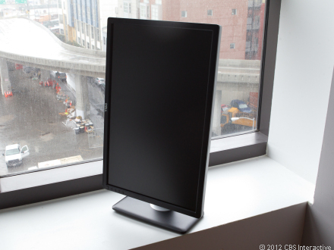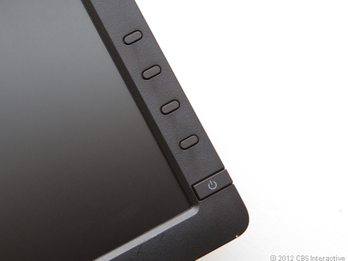
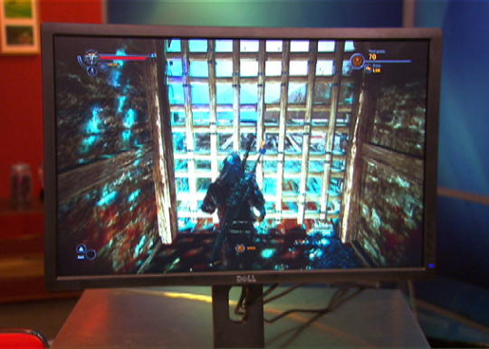
Scroll LeftScroll Right

CNET Editors' Review
- Want it (4)
- Got it (1)
- Had it (0)

CNET Editors' Rating
4.0 stars Excellent

- Design: 8.0
- Features: 8.0
- Performance: 8.0
- Service and support:8.0
- Reviewed by: Eric Franklin
- Reviewed on: 03/02/2012

Mar 12The good: The Dell UltraSharp U2412m has great performance with excellent ergonomic support and a robust and easy-to-navigate OSD with tons of options for customization. It also has five USB ports, and it's currently available for about $350.
The bad: HDMI is missing from the connection options, and performance-wise, it's not quite there compared with high-end, pro-grade IPS panels, especially when it comes to viewing angles.
The bottom line: With thoughtful design, great performance, and plenty of OSD features, the Dell UltraSharp U2412 fills its value quotient to the brim.

As the follow-up to 2009's Dell UltraSharp U2410, the U2412m has quite a bit to live up to. I expected Dell to stay on its high-end and expensive course it had already plotted for the series. Not surprisingly, I'll admit to being a bit disappointed when I learned Dell went with a cheaper IPS panel with the 2412m compared with its previous efforts.
Design and features
"Thin and light" aren't usually descriptors assigned to 24-inch In-Plane Switching (IPS) monitors, but in the curious case of the Dell UltraSharp U2412m, that's as apt a description of its physical attributes as I could think of.
Unlike the U2410 from 2009, the U2412m houses an LED backlight and uses an E-IPS panel as opposed to the H-IPS panel that the U2410 utilized. E-IPS panels are cheaper to manufacturer, but performance-wise, usually land between Twisted Nematic (TN) and H-IPS. Check out the performance section to see how true that is in this case.
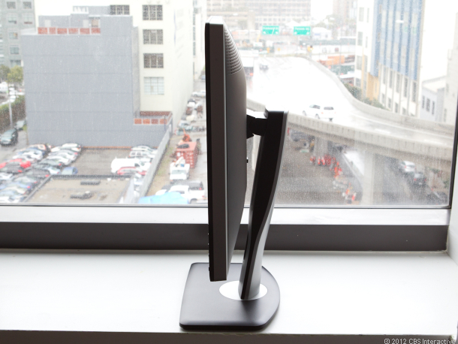
While not incredibly slim, that's a fairly slim profile for an IPS performance monitor.
The U2412m's LED backlight affords it a much thinner design than previous entries in the series. Initially, the panel measures 1.1 inches thick. It then tapers back toward the rear where another 1.6 inches house the connection options and ventilation system. This brings its collective depth to 2.7 inches; that's a little more than half an inch thinner than the U2410. At 13 pounds, again, we're seeing something uncharacteristic: a light IPS monitor. Unexpected, since they can easily top 20 pounds.
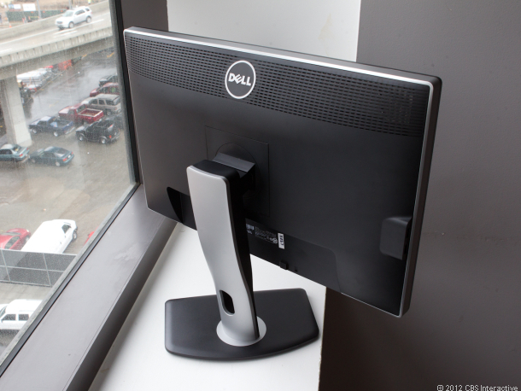
A 45-degree left and right swivel isn't enough to stop the downpour.
The left and right side bezel measures 0.7 inch each, and the full panel width is 21.9 inches. The foot stand sits 11 inches wide and 7.2 inches deep; however, knocking the panel from the sides yields ample wobbling on a flat surface. Not a necessarily earth-shattering discovery, given its light weight.
The U2412m sports a complete collection of ergonomic options, including a 90-degree pivot, 45-degree left and right swivel, and 20-degree back tilt. Also, there's 4.8 inches of screen height adjustment, with panel-to-desktop space measuring 1.3 inches at the bottom and 6.1 inches at the top.
Video connections options consist of DisplayPort, DVI, and VGA. The lack of HDMI is disappointing, but perhaps even more disappointing is the placement of the connections that are included. Connections on monitors should face out, not down, plain and simple. Many smaller monitors achieve this, as do pretty much all TVs. It's time we started seeing them on performance monitors. That said, the pivot feature makes slightly less blood drip from my nose when connecting the monitor.
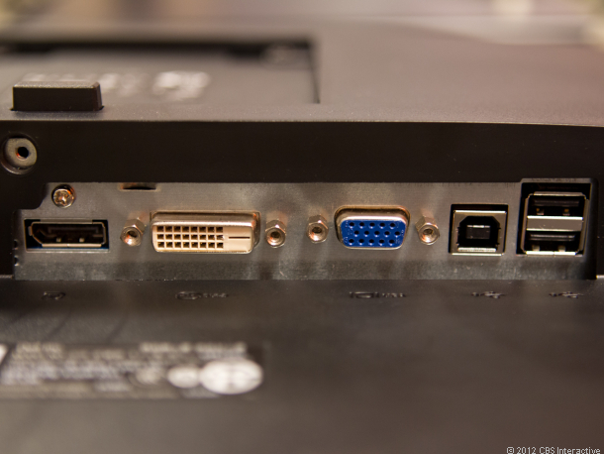
DisplayPort, DVI, VGA, USB upstream, and USB downstream x2. Sadly, no HDMI. No composite or component, either, but who cares about those? Seriously, though, the lack of HDMI speaks to a larger trend I've noticed with recent monitors. Could DisplayPort finally be in a position to take over as the primary computer video input?
The OSD array is aligned vertically along the lower-right bezel and consists of four small but well-spaced buttons. Navigating the OSD is simple and clean. Dell still makes the best-designed OSDs in the industry with a contextual navigation system that never lets you forget the function each button has at any given time.
Customizations are robust and vast, providing access to brightness, contrast, and sharpness. Its seven different presets consist of Standard, Multimedia, Movie, Game, Text, Color Temperature, and RGB. The color temperature preset allows for altering temperature values from 5,000 Kelvin up to 10,000K. The RGB preset allows you to access red, green, and blue values individually. One minor disappointment, however, is that you can't alter color temperature or RGB values when in a different preset. You can augment both hue and saturation, though.
For the energy conscious among you (all both of you), in the top-right corner of the OSD sits an energy use meter that gauges how much power the monitor is using. Also, there's an Energy Smart mode that lowers the brightness based on the amount of ambient light in the room.
Perhaps as a byproduct of being unaccustomed to such light IPS displays, it was difficult to get used to something (a well-performing IPS monitor) that felt so light and airy. In my mind, IPS monitors should be these weighty behemoths; experiencing the opposite was a bit off-putting. Admittedly, this is a crazy personal thing and doesn't really affect the monitor's quality.
 | Design and feature highlights
Connectivity: | DVI, DisplayPort, VGA
Ergonomic options: | 20 degree back tilt, 45 degree left and right swivel, 90 degree pivot, 4.5 inch height adjustment
Resolution: | 1,920x1,200 pixels
Aspect ratio: | 16:10
Audio: | n/a
VESA wall mount support: | Yes
Included video cables: | DVI, VGA
Backlight: | LED
Panel Type: | E-IPS
Screen film: | Matte
Number of presets: | 7
Overdrive: | No
Picture options: | Brightness, Contrast, Sharpness
Color controls: | RGB and six color-temperature options
Gamma control: | Yes
Additional features: | USB downstream x 4, USB upstream x 1
Performance
I tested the Dell UltraSharp U2712m through its DVI input, connected to a Windows Vista PC, using the included DVI cable. The display posted a composite score of 97 on CNET Labs' DisplayMate-based performance tests.
DisplayMate: The U2412m displayed light gray up to level 254; 255 is considered white and every level in-between it and 1 is a variation of gray, so 254 is about as high as you can get. The U2412m's performance here indicates that the display would retain its contrast ratio and likely not be prone to washing out light colors. As for dark gray, the U2412m just barely displayed down to level 2 while still maintaining a very deep black, pointing to the display being capable of retaining dark detail during dark scenes in movies.
The U2412m excelled in all of our color tests, showing a propensity for displaying color accurately and smoothly with no unexpected jumps in color scale progression.
In our Dark Screen test, we did see some light clouding in all four corners of the screen. And by "light" I mean "very little."
Text: Black text on white looked clear, without any obvious color tint problems. Also, fonts were clearly visible down to a 6.8-point size.
Read more: http://reviews.cnet.com/lcd-monitors/dell-ultrasharp-u2412m/4505-3174_7-35002356.html#ixzz1oSM0ULXy
Movies: I tested the Dell UltraSharp U2412m using the Blu-ray version of "Avatar." The movie preset provided a great movie-watching experience, displaying a high contrast and vibrant look with rich colors with appropriately deep blacks. No oversaturation or green tint problems were noticeable.
Games: When evaluating the look of games on a monitor, the two most important features to consider are vibrancy and color. If the monitor can display games with a bright and vibrant cleanness, this goes a long way toward benefiting its looks. If colors can also pop with fullness and depth, games can usually look great. Streaking is a different concern that honestly isn't very pervasive with most modern monitors, but if you're concerned about it, be sure to check out the last paragraph in this section.
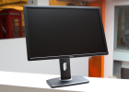
Photo gallery:
Dell UltraSharp U2412m
Different still is input lag, which is, put simply, the time it takes from when you input an action through your keyboard, mouse, or gamepad to when you see that action represented onscreen. Every monitor has a degree of input lag, but only a very small percentage of people would even notice it. Given that, it's not something I find valuable enough to test for. PSA, over.
Using the Game preset, Dragon Age II looked excellent on the U2412m with a high vibrancy and dramatic color pop. Same as movies, no obvious color tint problems were present.
To test refresh rate, I used DisplayMate's motion graphics tests and stared at a number of colored blocks as they moved around the screen at various speeds. The U2412m displayed large after-images of the blocks as they shifted across the screen, but I didn't notice this level of ghosting when actually playing games.
Photos: When looking at faces and light-colored hair, in the Standard preset the U2412m's colors sometimes dipped ever so slightly into a greenish hue, but the bright colors of clothing and environments popped with vibrancy.
Recommended settings: Each preset is tailored quite well for its task. For general use, however, I preferred the standard preset, adjusting only green to about 90 percent. This gave the monitor great color balance, perfect for general use.
Viewing angle: The optimal viewing angle for a monitor is usually directly in front, about a quarter of the screen's distance down from the top. At this angle, you're viewing colors as the manufacturer intended. Most monitors aren't designed to be viewed at any other angle. Depending on its panel type, picture quality at non-optimal angles varies. Most monitors use TN panels, which get overly bright or overly dark in parts of the screen when not viewed from optimal angles.
Anti-glare (AG) screen coating plays a part as well. Some viewers prefer the coating not be applied at all, while others favor only a limited amount. Still, others are completely indifferent; however, AG coating doesn't adversely affect quality and its merits, or lack thereof, are strictly a question of preference.
The U2412m uses an E-IPS panel, which provides it a wider-than-TN viewing angle that fails to match viewing angles seen on higher-end IPS panels.
The AG coating works fairly well here, keeping out most reflections; however, on a black screen viewed from an off angle, some blurry impressions of the environment are visible. Luckily, you'll likely have something on screen while you're using it, like, you know, images. So, this likely won't even be an issue. Actually, forget I said anything.
Power consumption: Armed with an LED backlight, the Dell UltraSharp U2412m achieved fair power consumption, with a Default/On power draw of 27.5 watts, compared with the Dell UltraSharp U2410's 63.69 watts in the same test.
In our Sleep/Standby test, the U2412m costs 0.59 watt and the U2410 pulled a lower 0.47 watt. Based on our formula, the U2412m would incur more than double the cost of the U2410, with a per-year pull of $19.32, compared with the U2410's $8.63 per year.
Brightness (in cd/m2)
(Longer bars indicate better performance)
Brightness
Dell Ultrasharp U2410
434
Asus PA246Q
361
Lacie 324i
358
Samsung SyncMaster PX2370
344
Dell Ultrasharp U2412m
300
HP DreamColor LP2480zx
230
Contrast ratio
(Longer bars indicate better performance)
Dell Ultrasharp U2412m
1,155:1
HP DreamColor LP2480zx
1,036:1
Samsung SyncMaster PX2370
1,008:1
Lacie 324i
937:1
Dell Ultrasharp U2410
921:1
Asus PA246Q
792:1
DisplayMate performance test
(Longer bars indicate better performance)
HP DreamColor LP2480zx
98
Dell Ultrasharp U2412m
97
Lacie 324i
97
Asus PA246Q
96
Samsung SyncMaster PX2370
96
Dell Ultrasharp U2410
94
Juice box
Dell UltraSharp U2712m | Average watts per hour
On (default luminance) | 27.5
On (max luminance) | 35.1
On (min luminance) | 14.4
Sleep | 0.59
Calibrated (200 cd/m2) | 25.6
Annual power consumption cost | $8.63
Score | Fair
Find out more about how we test LCD monitors
Service and support
Dell backs the U2410mwith a solid warranty, including a three-year parts and labor warranty covering the backlight. It also offers support through a 24-7 toll-free number and 24-7 Web chat. Dell also has a fast 24- to 48-hour e-mail turnaround time--a better package than most monitor vendors, which don't offer weekend support.
Conclusion
When it comes to value, there are few monitors that show up like the U2412m does. It includes a great list of ergonomic features, plenty of useful OSD customizations, and good performance at a great price.
HDMI will be missed, and while it won't quite match high-end monitors in viewing angle performance, most users wouldn't even notice the difference. Professionals who rely on pinpoint accuracy, however, will want to spend a bit more money to get something that better aligns to their needs.
Read more: http://reviews.cnet.com/lcd-monitors/dell-ultrasharp-u2412m/4505-3174_7-35002356-2.html#ixzz1oSMBpI00
Specifications:
- Manufacturer: Dell, Inc.
- Part Number:320-2676

General
- Display Type TFT active matrix
- Diagonal Size 24 in
- Viewable Size 24 in
- Built-in Devices USB hub
- Panel Type IPS
- Aspect Ratio Widescreen - 16:10
- Native Resolution 1920 x 1200 at 60 Hz
- Pixel Pitch 0.27 mm
- Brightness 300 cd/m2
- Image Contrast Ratio 1000:1 / 2000000:1 (dynamic)
- Color Support 16.7 million colors
- Response Time 8 ms
- Horizontal Viewing Angle 178
- Vertical Viewing Angle 178
- Screen Coating 3H Hard Coating ,
Anti-glare
- Backlight Technology LED backlight
- Controls & Adjustments Brightness,
Contrast,
Color temperature
- Features HDCP,
82% (CIE 1976) color gamut,
UltraSharp
- Dimensions (WxDxH) 21.9 in x 7.1 in x 20.2 in - With stand
- Weight 13.7 lbs

Connectivity
- Interfaces VGA,
DVI-D,
DisplayPort,
USB 2.0 upstream ( Type B ),
USB 2.0 downstream

Mechanical
- Display Position Adjustments Tilt,
Swivel,
Pivot (rotation),
Height
- Height Adjustment 4.5 in

Miscellaneous
- Features Security lock slot (cable lock sold separately),
Integrated cable management,
Wall mountable
- Cables Included 1 x DVI cable,
1 x VGA cable,
1 x USB cable
- Microsoft Certifications Compatible with Windows 7
- Compliant Standards TCO Certified Edge

Power
- Voltage Required AC 120/230 V ( 50/60 Hz )
- Power Consumption Operational 38 Watt

Software / System Requirements
- Software type PowerNap

Dimensions & Weight
- Dimensions & Weight Details Without stand - 21.9 in x 2.6 in x 14.3 in x 8.8 lbs,
With stand - 21.9 in x 7.1 in x 20.2 in x 13.7 lbs

Environmental Parameters
- Min operating temperature 32 °F
- Max operating temperature 104 °F
- Operating humidity range 10 - 80% (non-condensing)

Sustainability
- CNET Labs: Operational power consumption 27.5 Watt
- CNET Labs: Calibrated power consumption 25.6 Watt
- CNET Labs: Max brightness power consumption calibrated 35.1 Watt
- CNET Labs: Min brightness power consumption 14.4 Watt
- CNET Labs: Power consumption Stand by / Sleep 0.59 Watt
- CNET Labs: Estimated Annual Energy Cost 8.19 US Dollars
- EPA Energy Star Compliant Yes
- EPEAT Compliant EPEAT Gold

Asus PA246Q
- Review
- User Reviews
- Specifications
- Compare
- Shop

CNET Editors' Rating
4.0 stars

Excellent

Average User Rating
4.0 stars
5 reviews
Starting at: $479.00
- $499.99
Newegg.com
- $539.95
Cascio Interstate Music
- $479.00
B&H Photo-Video
- $489.57
Amazon.com
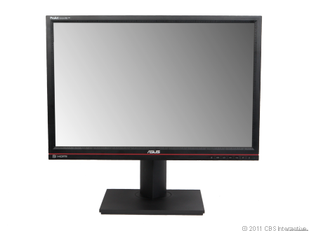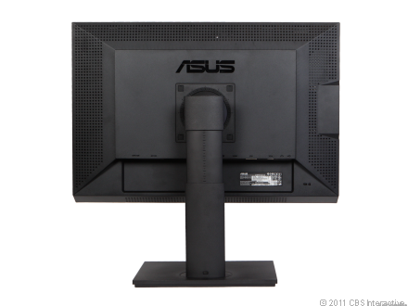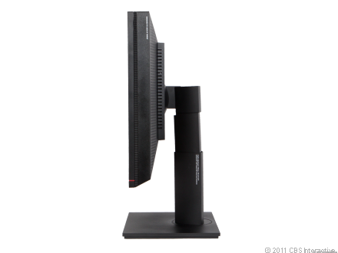
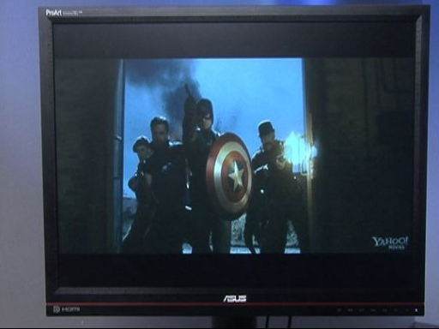
Scroll LeftScroll Right

CNET Editors' Review
- Want it (7)
- Got it (0)
- Had it (0)

CNET Editors' Rating
4.0 stars Excellent

- Design: 7.0
- Features: 9.0
- Performance: 8.0
- Service and support:8.0
- Reviewed by: Eric Franklin
- Reviewed on: 06/23/2011

Jun 11The good: The Asus PA246Q has terrific performance with vibrant colors in games and movies. Its robust OSD offers detailed customization options and a unique overlay feature that provides extra graphical precision. Lastly, the monitor has full ergonomic support and a relatively affordable price.
The bad: The PA246Q's powerful backlight prevents really deep blacks from being attained, and there's a consistent color imperfection that gives most images a slight reddish hue. More connection options would have been useful.
The bottom line: The Editors' Choice Award-winning Asus PA246Q is a professional-class monitor with a satisfying number of features at an affordable price.

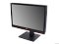
Photo gallery:
Asus PA246Q
There are three distinct reasons to be excited about the Asus PA246Q. One, it's the first monitor we've had the opportunity to calibrate using a new tool (some details below); two, it's the first 24-inch-plus monitor with a high-end P-IPS panel we've reviewed that costs less than $500.
Finally, the graphical overlay feature may be the most original monitor option I've encountered in more than three years of writing monitor reviews. Essentially, the feature places one of a number of different grid and photo size options on the screen, allowing for increased precision when tailoring graphics or printing photos.
Anyway, keep reading to see if the above-mentioned features were just a cheap bid for attention or if the PA246Q is worth the relatively small amount of cash Asus is asking for.
Design and features
In the top-left corner of the 24-inch Asus PA246Q's chassis, written in white text, is the word "ProArt." If there was any ambiguity about the type of user Asus is targeting with this monitor, this small design touch should abolish it. Like most "Pro" monitors, the PA246Q houses a Professional In-Plane Switching (P-IPS) panel. This makes for a monitor with more girth than the comparatively small Twisted Nematic (TN)-based displays, which aren't as suited for professional art tasks. The P-IPS panel, with its Cold Cathode Fluorescent Lamp (CCFL) backlight, measures a deep 3.2 inches in depth.
The bezel is 0.75 inch on the left and right sides with the full width of the panel checking in at 22 inches. Aligned along the bezel are numberless, rulerlike measurement notches that we can safely say we've never seen on a monitor before. This precision motif continues at the base of the display's neck where a circular dial resides with measuring notches arranged along its perimeter. No numbers appear on the dial, but there is an arrow above it that acts as a measurement guide and allows for precise swiveling of the panel.
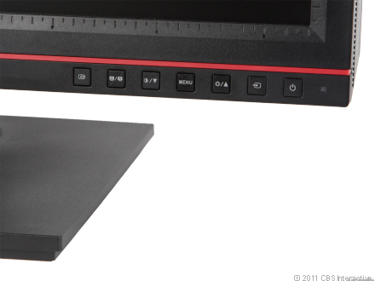
Located above the OSD array, the measurement notches may assist in accuracy and precision when designing.
Speaking of which, the monitor can swivel 60 degrees left and right, tilt back 20 degrees, and pivot 90 degrees, and its screen height can be adjusted by 4 inches. The foot stand is fairly flat, is close to square in shape, and measures 11 inches wide by 9.25 inches deep. Even given this wide foot stand, the display wobbles quite a bit when knocked from the sides.
The build quality of the boxy, dark-gray chassis feels quite substantial--a surprising impression, given that the PA246Q weighs 17 pounds, whereas other 24-inch IPS monitors typically weigh 20 pounds or more.
Along the monitor's left side, aligned vertically, are two USB downstream ports and a multimedia card reader. Back connections include DVI, DisplayPort, VGA, HDMI, USB upstream, and a headphone jack. There's also a power switch, hidden away on the right side. While this provides us one each of the fab four of video connections, we could have used a few more duplicates of connection options.
The onscreen display (OSD) array consists of six buttons including Quickfit, a preset shortcut, a down button, an up bottom, a Menu button, and an Enter button. The buttons are separated from each other by a button's width of space and all emit a satisfying pop when pressed.
Navigating the OSD takes a little while to get the hang of, but fortunately, it includes contextual icons to steer you in the right direction. The OSD features Standard, sRGB, Adobe RGB, Scenery mode, and Theater mode presets, plus an additional customizable User Mode. Also included are brightness, contrast, saturation, hue, gamma, and advanced color settings including six-color hue and saturation adjustment controls and direct RGB color control using gain and offset. Rounding out the more useful options are sharpness and aspect ratio control, picture-in-picture (PIP) settings, and system setup options such as OSD window placement and duration onscreen.
By far the most unusual feature in the PA246Q's already considerable assembly of OSD options is Quickfit. Pressing the Quickfit button places an overlay on the screen of your choice of either grid patterns (of various dimensions) or paper and photo sizes. With the grid patterns you can more precisely and consistently organize content on a page when, say, designing graphics for the Web.
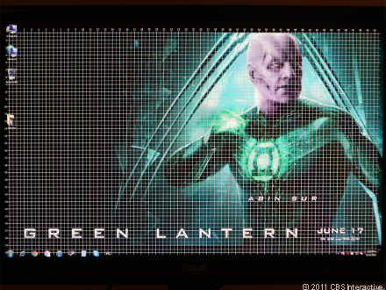
Excellent for designing D&D dungeons, yes, but also useful when consistent asset placement is necessary.
The paper and photo sizes would show exactly what papers and photos will look like once printed. This one seems less useful, as any self-respecting graphic artist would probably already be using Photoshop or some other program to do this. Still, it's a unique option that some will get more out of than others.
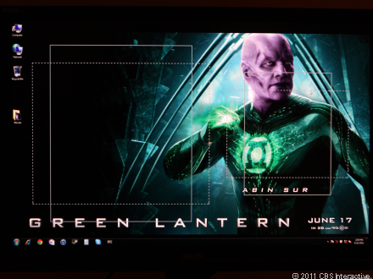
Sizing photos has never been as easy; well, maybe in Photoshop.
Design and feature highlights
Connectivity | DVI, VGA, HDMI, DisplayPort
Ergonomic options | 20-degree back tilt, 5-degree front tilt, 60-degree swivel, 90-degree pivot
Resolution | 1,920x1,200 pixels
Aspect ratio: | 16:10
Audio | Headphone jack
VESA wall-mount support | Yes
Included video cables | DVI, VGA
Backlight | CCFL
Panel type | P-IPS
Screen film | Matte w/AG coating
Pixel-response rate | 0.270mm
Number of presets | 6
Overdrive | No
Picture options | Brightness, Contrast, Saturation, Hue
Color controls | RGB and Warm, Cool, Medium
Gamma control | No
Additional features | Grid, photo- and paper-size overlays
Performance
We tested the Asus PA246Q through its DVI input, connected to a Windows Vista PC, using the included DVI cable. The display posted a composite score of 96 in CNET Labs' DisplayMate-based performance tests.
DisplayMate: The Asus PA246Q displayed light gray up to level 253, but level 254 was indistinguishable from white. At the lower end of the grayscale, the monitor succeeded in showing dark gray down to a level of only 6, indicating that shadow detail would elude the PA246Q.
In Color Tracking we noticed a red hue in the grayscale that persisted in every other preset to varying degrees; the SRGB preset showed the least amount of off color.
Read more: http://reviews.cnet.com/lcd-monitors/asus-pa246q/4505-3174_7-34505604.html#ixzz1oSMg0ABn
Screen uniformity and backlight bleeding levels were not as impressively low as on the HP DreamColor LP2480zx. When viewing our Dark Screen test, which consists of a plain black screen, we saw a small amount of light bleed through in the lower-left and upper-left corners of the screen. On the whole, especially when compared with the pitch-black screen of the HP LP2480zx, the screen gave the impression of a bright light held behind a moderately thick black curtain. It's not egregious, but the look of subtly veiled light is apparent.
Text: In text, we saw no color problems with black text on a white background. Fonts were clearly visible down to a 6.8-point size.
Movies: We tested the Asus PA246Q using the Blu-ray version of "Avatar." The Theater preset displayed the movie with a blue hue and crushed many dark grays to the point where some dark detail was impossible to see. This preset does seem to increase the level of contrast between the dark and light parts of the screen, but the severe loss of dark detail was unacceptable.
For a more balanced image where dark gray isn't crushed so severely and colors--while not as vibrant--are more accurate, check out our recommended settings below.
Games: When evaluating the look of games on a monitor, the two most important features to consider are vibrancy and color. If the monitor can display games with a bright, clean vibrancy, this goes a long way. If colors also pop with fullness and depth, games will usually look great. We looked at StarCraft II on the Asus PA246Q and saw color and vibrancy nearly on par with the LP2480zx. Also, character detail was smooth and sharp with no egregious aliasing such as we've seen happen on some monitors where the high sharpness introduces too much noise into the image. See below for our recommended settings.
To test refresh rate, we used DisplayMate's motion graphics tests and watched a bunch of graphics fly around the screen, looking for evidence of streaking. Although the PA246Q displayed less streaking than the LP2480zx, the Asus monitor did show noticeably more streaking than we saw on the Samsung PX2370--admittedly, a monitor with a faster refresh rate.
Photos: Faces in photos looked alive with none of the green hue problems that have plagued recent monitors we've reviewed. However, the PA246Q's color couldn't match the richness of the HP LP2480zx, which delivered color with a fullness we've rarely seen on a display. Keep in mind, though, that the LP2480zx costs more than five times as much as the PA246Q, a fact that makes the Asus PA246Q's performance even more impressive.
Recommended settings: We used SpectraCal's CalPC to calibrate the Asus PA246Q for bright-room viewing. The following monitor settings were the result.
Attribute | Setting
Preset | User Mode
Brightness | 14
Contrast | 85
Color temperature | 6500K
Gain | R-50
 | G-50
 | B-53
Offset | R-76
 | G-44
 | B-31
If performance with these settings is still unsatisfactory, try the sRGB mode, as it was the most accurate of the presets.
Viewing angle: The optimal viewing angle for a monitor is usually from directly in front, about a quarter of the screen's distance down from the top. At this angle, you're viewing colors as the manufacturer intended. Most monitors aren't designed to be viewed at any other angle. Depending on its panel type, picture quality at nonoptimal angles varies. Most monitors use TN panels, which get overly bright or overly dark in parts of the screen when not viewed from optimal angles.
The Asus PA246Q uses a P-IPS panel, so it has a wide viewing angle from all sides. The antiglare coating works fairly well here, keeping out most reflections; however, on a black screen viewed from an angle, some blurry impressions of the environment are visible.
Power consumption: The Asus PA246Q's power consumption earned a rating of Poor, with a Default/On power draw of 71.6 watts, compared with the HP DreamColor LP2480zx's 62.63 watts in the same test. It's not at all surprising that two CCFL-based monitors with IPS panels would require that kind of power.
In our Sleep/Standby test, the PA246Q drew 1.04 watts and the LP2480zx pulled a higher 1.97 watts. We expected the monitors to cost nearly the same per year to run, and based on our formula, the PA246Q would cost $22.08 per year, whereas the LP2480zx would cost $20.05 per year.
Juice box
Asus PA246Q | Average watts per hour
On (default luminance) | 71.6
On (max luminance) | 83.1
On (min luminance) | 42.1
Sleep | 1.04
Calibrated (200 cd/m2) | 61.5
Annual power consumption cost | $22.08
Score | Poor
Brightness in cd/m2
(Longer bars indicate better performance)
Dell UltraSharp U2410
434
Asus PA246Q
361
LaCie 324i
358
NEC MultiSync PA271W
346
Samsung SyncMaster PX2370
344
Dell UltraSharp U2711
333
HP DreamColor LP2480zx
230

Contrast ratio
(Longer bars indicate better performance)
HP DreamColor LP2480zx
1,036:1
NEC MultiSync PA271W
1,035:1
Samsung SyncMaster PX2370
1,008:1
Dell UltraSharp U2711
947:1
LaCie 324i
937:1
Dell UltraSharp U2410
921:1
Asus PA246Q
792:1

DisplayMate performance tests
(Longer bars indicate better performance)
HP DreamColor LP2480zx
98
NEC MultiSync PA271W
98
Dell UltraSharp U2711
98
LaCie 324i
97
Asus PA246Q
96
Samsung SyncMaster PX2370
96
Dell UltraSharp U2410
94
Find out more about how we test LCD monitors.
Service and support
Asus backs the PA246Q with a three-year casing-and-panel warranty that covers the backlight. This includes its Zero Bright Dot guarantee, which ensures full monitor replacement if any stuck pixels are found. The company also offers support through a 24-7 toll-free number, e-mail, and Web chat. At the time of this review, no drivers or manuals were available on the company's Web site for the PA246Q; that's surprising, given that the monitor was released weeks ago. That's not a deal breaker, of course--the monitor does come with these files--but an online repository for such support is always welcome. Hopefully Asus will post the files soon.
Conclusions
At $500, the Asus PA246Q is an incredible deal. Its P-IPS screen affords accurate colors and a wide viewing angle. The OSD is robust, and the overlay feature, although somewhat limited in its usefulness, is an interesting feature that some users will appreciate. Also, the fabulous four of ergonomic features are present.
The backlight does prevent truly deep blacks, and a persistent red-hue color imperfection defied our attempts to eradicate it. Also, more connection options would have been nice. But the Asus PA246Q has a fantastic price, performance that rivals more-expensive monitors, and enough features to satisfy professional monitor users and enthusiasts, winning it an Editors' Choice Award.
Read more: http://reviews.cnet.com/lcd-monitors/asus-pa246q/4505-3174_7-34505604-2.html#ixzz1oSMrikj8
Specifications:
- Manufacturer: Asus
- Part Number:PA246Q

General
- Display Type TFT active matrix
- Diagonal Size 24.1 in
- Built-in Devices 7-in-1 card reader
- Panel Type P-IPS
- Aspect Ratio Widescreen - 16:10
- Native Resolution 1080p 1920 x 1200
- Pixel Pitch 0.27 mm
- Brightness 400 cd/m2
- Image Contrast Ratio 50000:1 (dynamic)
- Color Support 1.07 billion colors
- Response Time 6 ms
- Vertical Refresh Rate 76 Hz
- Horizontal Refresh Rate 83 kHz
- Horizontal Viewing Angle 178
- Vertical Viewing Angle 178
- Controls & Adjustments Color temperature,
Input select,
Color balance,
Aspect control,
Brightness,
Contrast
- Features 98% Adobe RGB color gamut,
HDCP,
Picture in picture,
Trace Free Technology,
100% sRGB (CIE 1976) color gamut,
Color Rich Technology,
ASUS Splendid Video Intelligence Technology,
ASUS Splendid Video Preset Mode,
102% NTSC color gamut
- Color Black
- Dimensions (WxDxH) 22 in x 9.3 in x 15 in
- Weight 16.1 lbs

Input
- Type None

Connectivity
- Interfaces VGA,
DVI-D,
Headphones,
DisplayPort,
HDMI,
USB downstream,
USB upstream ( Type B )

Mechanical
- Display Position Adjustments Tilt
- Tilt Angle 25
- Flat Panel Mount Interface 100 x 100 mm

Miscellaneous
- Features Security lock slot (cable lock sold separately),
Pivot adjustment,
Tilt adjustment,
Wall mountable,
Swivel adjustment,
Adjustable height
- Cables Included 1 x VGA cable,
1 x DVI cable,
1 x Display cable,
1 x USB cable
- Microsoft Certifications Compatible with Windows 7
- Compliant Standards ErP Ready,
C-Tick,
TUV GS,
VCCI,
BSMI,
FCC,
PSE Mark,
CCC,
cUL,
UL,
TUV Ergo,
PSB,
WHQL,
TCO '03,
CB,
ISO 9241-307,
J-MOSS,
RoHS,
GOST-R

Power
- Power Consumption Operational 75 Watt
- Power Consumption Stand by / Sleep 1 Watt

Manufacturer Warranty
- Service & Support 3 years warranty
- Service & Support Details Limited warranty - 3 years,
Limited warranty - LCD panel - 3 years

Sustainability
- CNET Labs: Operational power consumption 71.6 Watt
- CNET Labs: Calibrated power consumption 61.5 Watt
- CNET Labs: Max brightness power consumption calibrated 83.1 Watt
- CNET Labs: Min brightness power consumption 42.1 Watt
- CNET Labs: Power consumption Stand by / Sleep 1.04 Watt
- CNET Labs: Estimated Annual Energy Cost 19.40 US Dollars

SIMILAR MONITORS – SPECIFICATIONS

Dell 27”

- Manufacturer: Dell, Inc.
- Part Number:G615T

General
- Display Type TFT active matrix
- Diagonal Size 27 in
- Viewable Size 27 in
- Built-in Devices Card reader ,
USB hub
- Panel Type IPS
- Aspect Ratio Widescreen
- Native Resolution 2560 x 1440 at 60 Hz
- Pixel Pitch 0.2331 mm
- Brightness 350 cd/m2
- Image Contrast Ratio 1000:1 / 80000:1 (dynamic)
- Color Support 1.07 billion colors
- Response Time 12 ms (typical); 6 ms (gray-to-gray)
- Vertical Refresh Rate 76 Hz
- Horizontal Refresh Rate 89 kHz
- Horizontal Viewing Angle 178
- Vertical Viewing Angle 178
- Screen Coating Anti-glare ,
Hard coating
- Backlight Technology Cold Cathode Fluorescent Lamp (CCFL)
- Controls & Adjustments Input select,
Brightness,
Contrast
- Features HDCP,
110% NTSC color gamut,
100% sRGB (CIE 1976) color gamut,
96% Adobe RGB color gamut,
UltraSharp
- Dimensions (WxDxH) 25.5 in x 7.9 in x 16.9 in - With stand
- Weight 23.1 lbs

Connectivity
- Interfaces VGA,
DVI-D (dual link),
DisplayPort,
USB 2.0 downstream,
USB 2.0 upstream ( Type B ),
HDMI,
Composite video,
Component video ( RCA x 3 ),
Audio line-out

Mechanical
- Display Position Adjustments Tilt,
Swivel,
Height
- Flat Panel Mount Interface 100 x 100 mm

Miscellaneous
- Features Security lock slot (cable lock sold separately)
- Cables Included 1 x DVI cable,
1 x VGA cable,
1 x DisplayPort cable
- Microsoft Certifications Compatible with Windows 7
- Compliant Standards Plug and Play,
TCO '03,
VESA DPMS

Power
- Form Factor Internal
- Voltage Required AC 120/230 V ( 50/60 Hz )
- Power Consumption Operational 113 Watt
- Power Consumption Stand by / Sleep 2 Watt

Software / System Requirements
- Software type Drivers & Utilities

Dimensions & Weight
- Dimensions & Weight Details With stand - 25.5 in x 7.9 in x 16.9 in x 23.1 lbs,
Without stand - 25.5 in x 3.7 in x 15.2 in x 17 lbs

Environmental Parameters
- Min operating temperature 32 °F
- Max operating temperature 104 °F
- Operating humidity range 10 - 80% (non-condensing)

Sustainability
- CNET Labs: Operational power consumption 93.72 Watt
- CNET Labs: Calibrated power consumption 81.8 Watt
- CNET Labs: Max brightness power consumption calibrated 115.3 Watt
- CNET Labs: Min brightness power consumption 41.89 Watt
- CNET Labs: Power consumption Stand by / Sleep 1.19 Watt
- CNET Labs: Estimated Annual Energy Cost 25.67 US Dollars

SAMSUNG 23”
- Manufacturer: Samsung
- Part Number:PX2370

General
- Display Type TFT active matrix
- Diagonal Size 23 in
- Aspect Ratio Widescreen
- Native Resolution 1080p 1920 x 1080
- Brightness 250 cd/m2
- Image Contrast Ratio 1000:1 / 5000000:1 (dynamic)
- Color Support 16.7 million colors
- Response Time 2 ms
- Horizontal Viewing Angle 170
- Vertical Viewing Angle 160
- Backlight Technology LED backlight
- Controls & Adjustments Power on/off
- Features Magic Lux,
sRGB color management,
MagicEco,
MagicReturn,
MagicAngle,
MagicTune,
Power off timer,
MagicWizard,
MagicBright 3
- Color Black
- Dimensions (WxDxH) 21.9 in x 9.2 in x 17.1 in - With stand
- Weight 9 lbs

Input
- Type None

Connectivity
- Interfaces SPDIF output,
DVI-I,
Audio line-out,
HDMI,
VGA
- Connections - DVI-I,
- Analog RGB,
- DVI,
- HDMI,
- SOG,
- Audio line-out,
- Optical output

Mechanical
- Display Position Adjustments Tilt

Miscellaneous
- Microsoft Certifications Certified for Windows Vista

Power
- Form Factor External
- Power Consumption Operational 25 Watt
- Power Consumption Stand by / Sleep 0.3 Watt

Dimensions & Weight
- Dimensions & Weight Details With stand - 21.9 in x 9.2 in x 17.1 in x 9 lbs,
Without stand - 21.9 in x 1 in x 13.3 in

Sustainability
- CNET Power Saver Yes
- CNET Labs: Operational power consumption 25.01 Watt
- CNET Labs: Calibrated power consumption 19.9 Watt
- CNET Labs: Max brightness power consumption calibrated 25.01 Watt
- CNET Labs: Min brightness power consumption 11.6 Watt
- CNET Labs: Power consumption Stand by / Sleep 0.27 Watt
- CNET Labs: Estimated Annual Energy Cost 6.23 US Dollars
- EPA Energy Star Compliant Yes
- EPEAT Compliant EPEAT Gold

